NAME – AMAN JAIN
Assignment 1
Exercise 1
1.
a). echo hello world
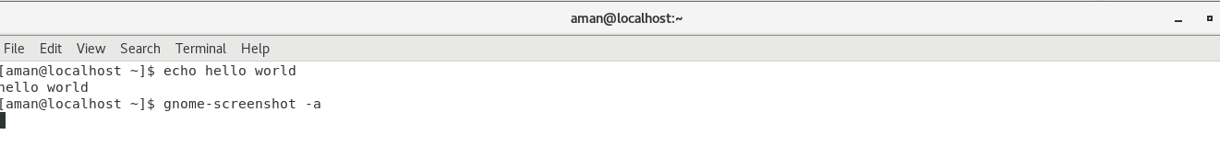
b). passwd
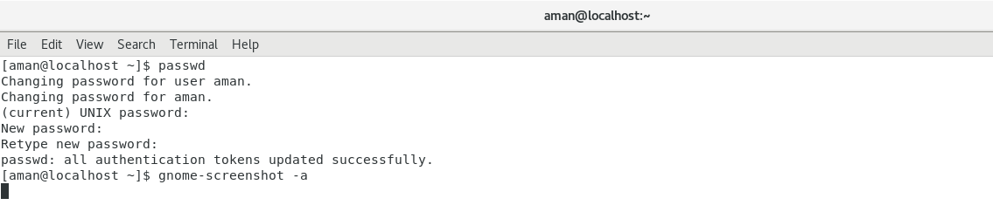
c). date
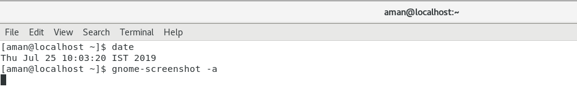
d). hostname
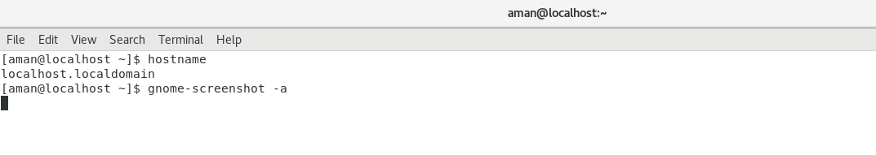
e). arch
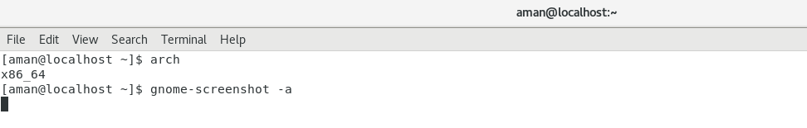
f). uname a
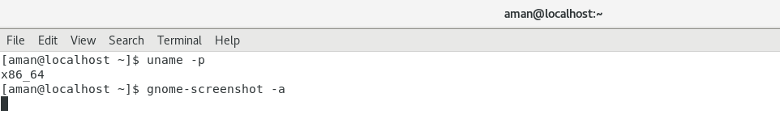
g) dmseg|more
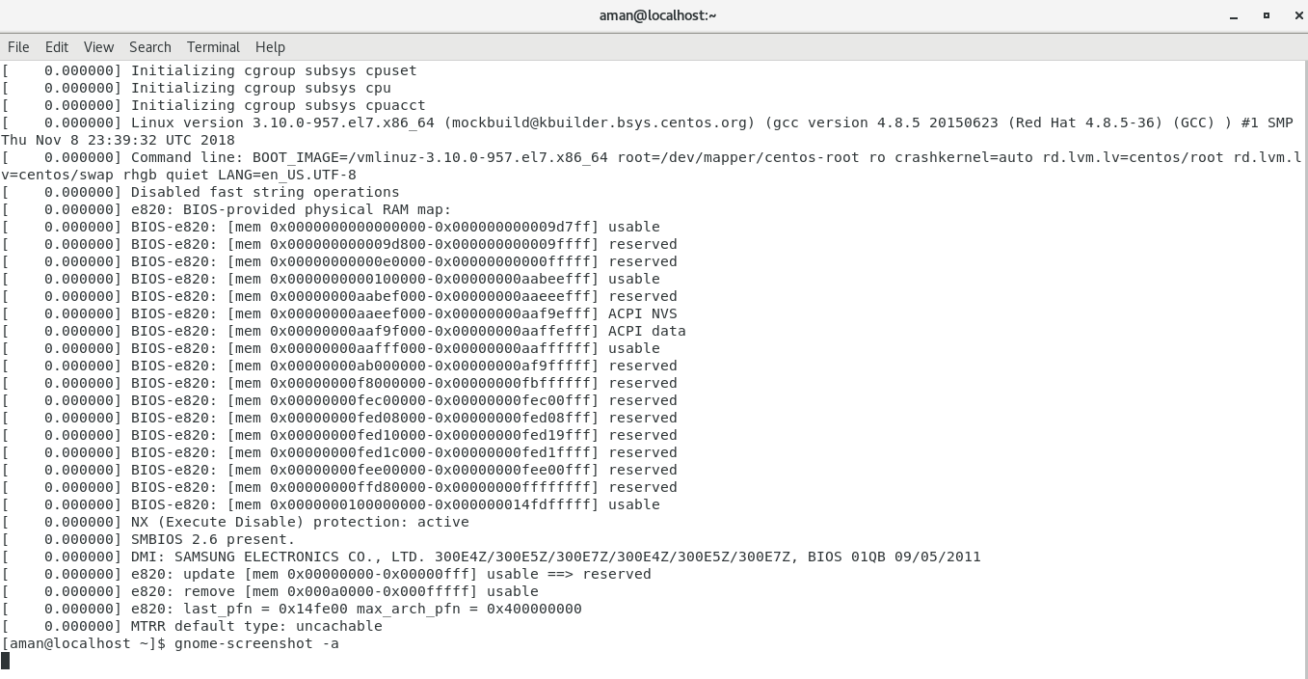
h). uptime
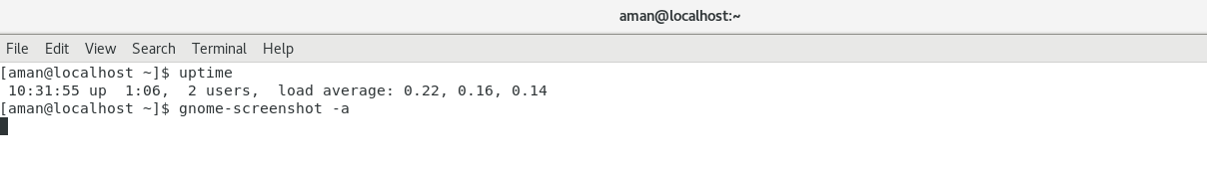
i).who am i
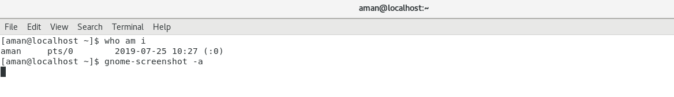
j).who
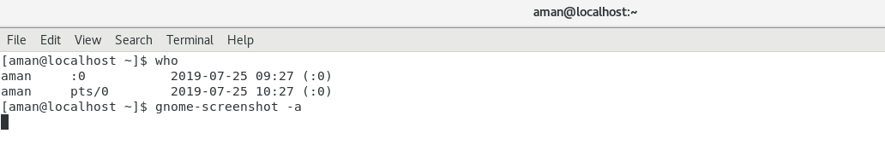
k).id
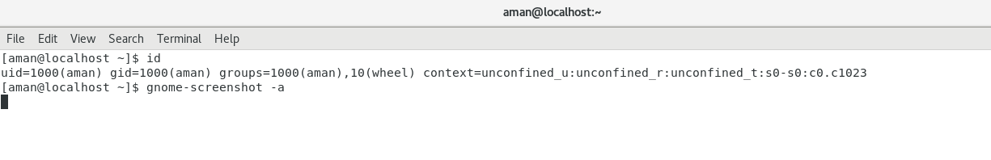
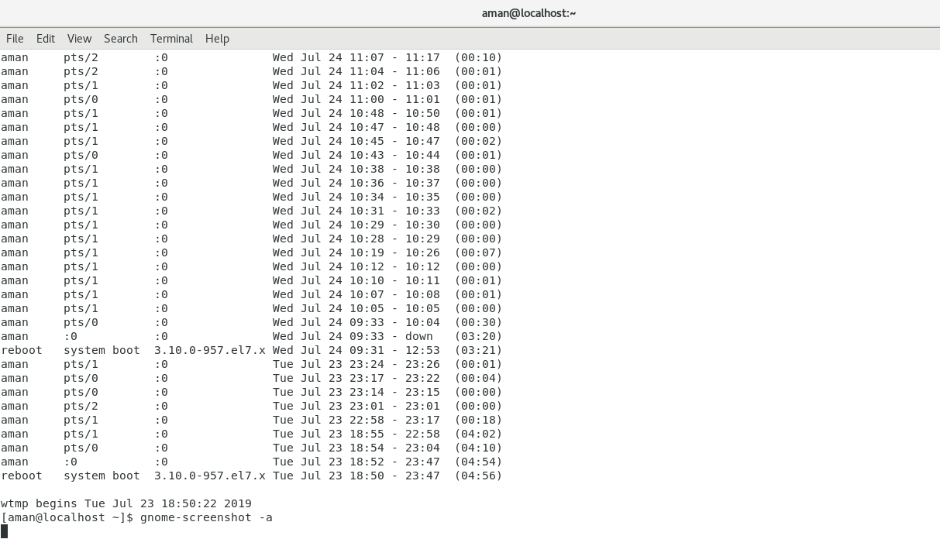
l).last
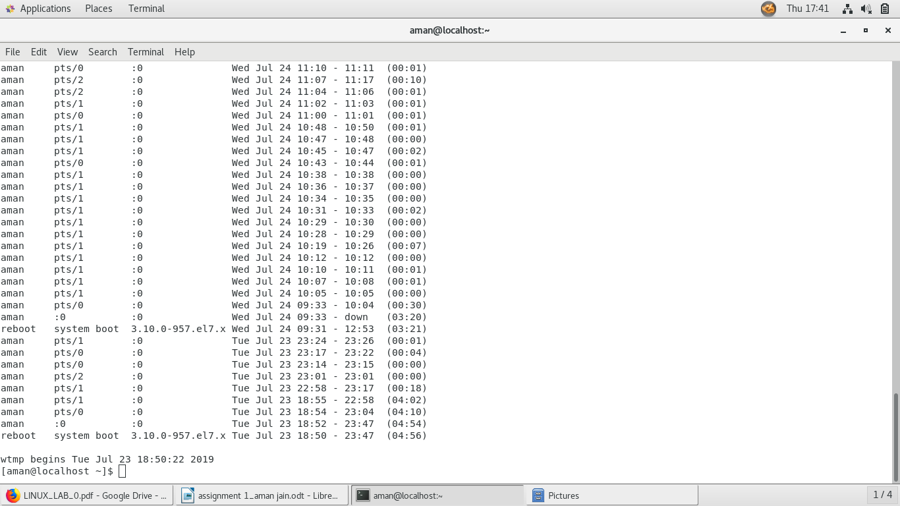

n).top
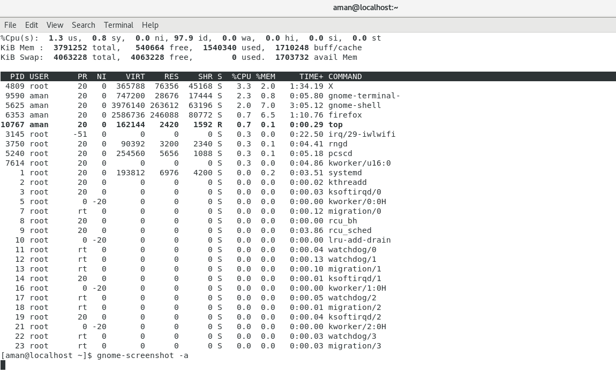
o). echo $SHELL
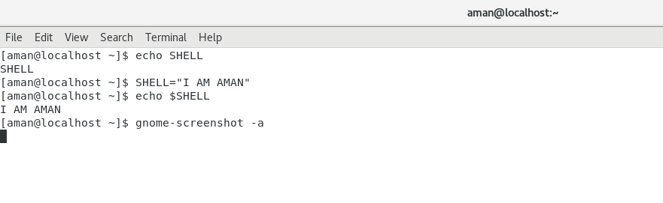

p).man ls
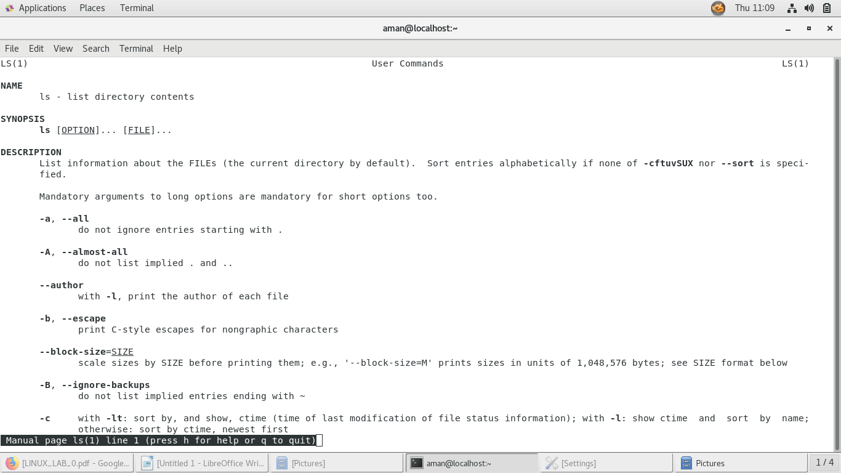
q).man who
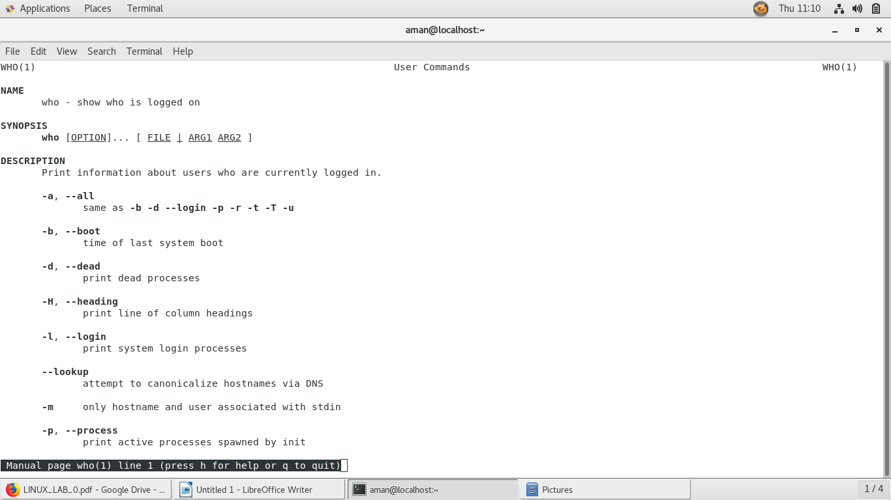

r).clear
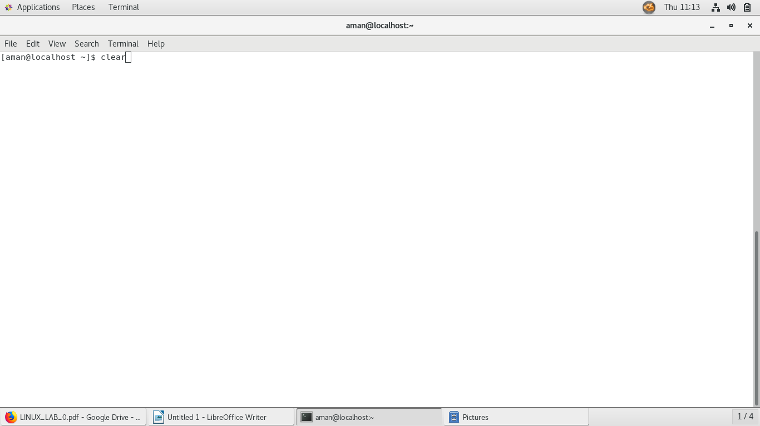
s). cal 2000
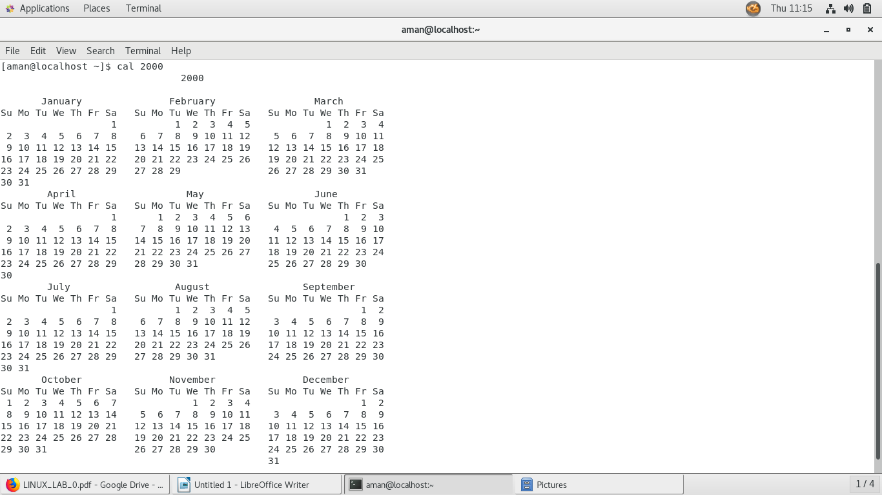

t). cal 9 1752
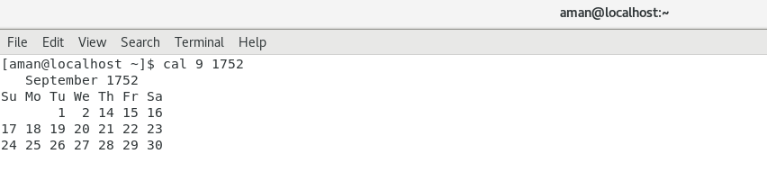
u).bc
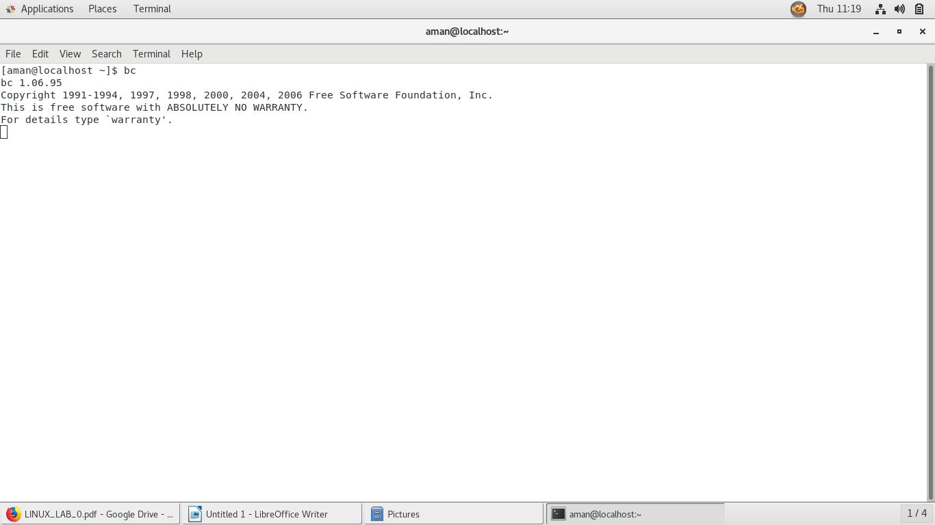
v).try echo 4+5 and echo 5+4
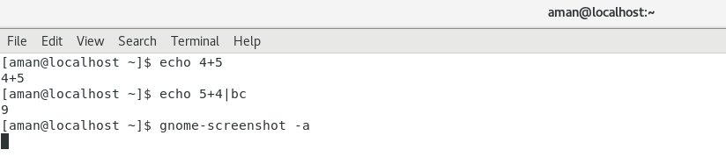
w).time sleep 5
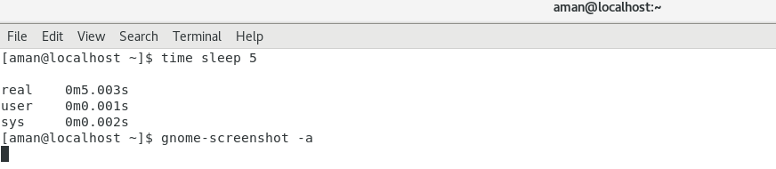

x).history
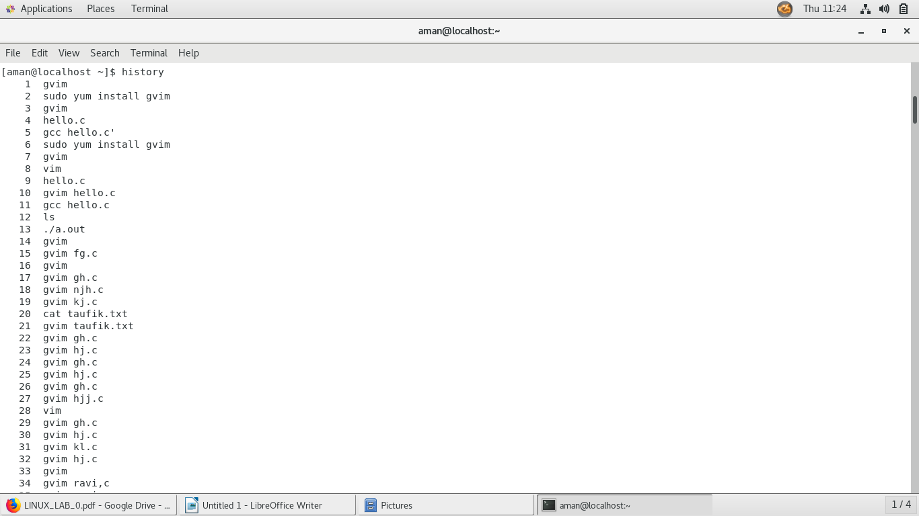
2).
a)Cd
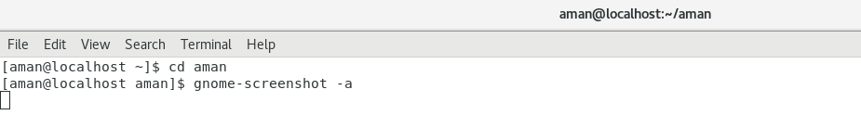
b).Pwd
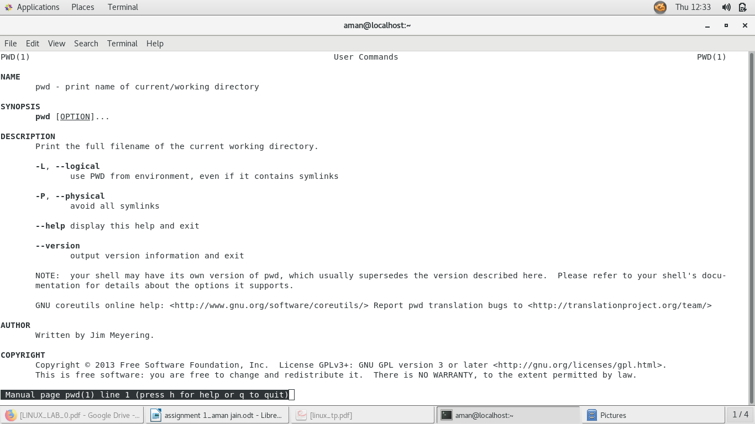

c).ls al
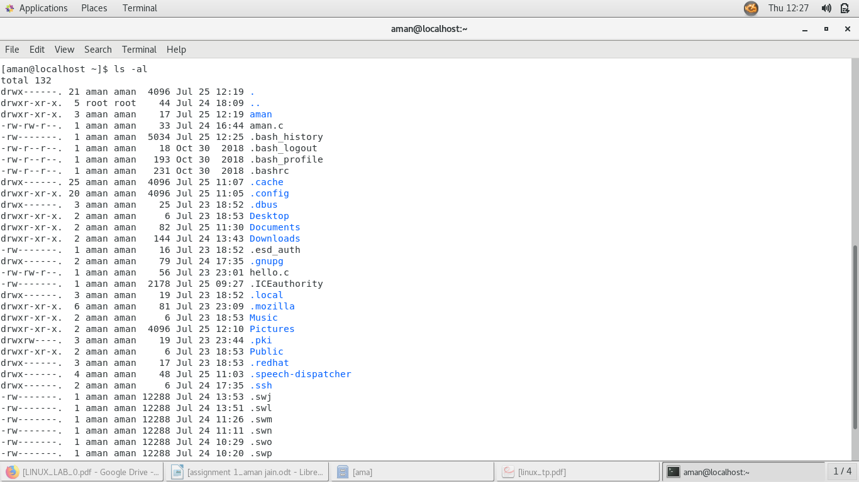
d).cd.
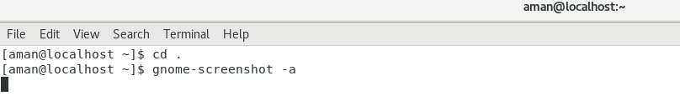

e).pwd
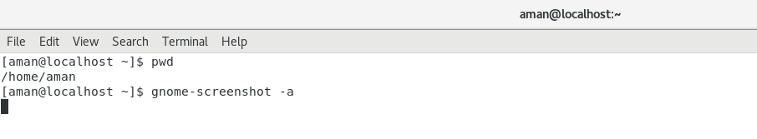
f).cd..
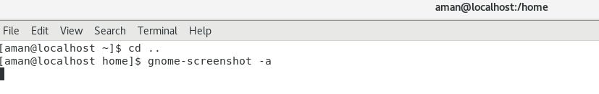

g).pwd
h).ls al
I).cd..
j).pwd
k)1.ls al
l).cd..
m).pwd
n).cd /etc
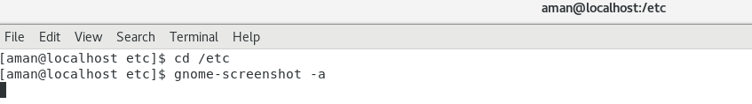
o).ls al|more
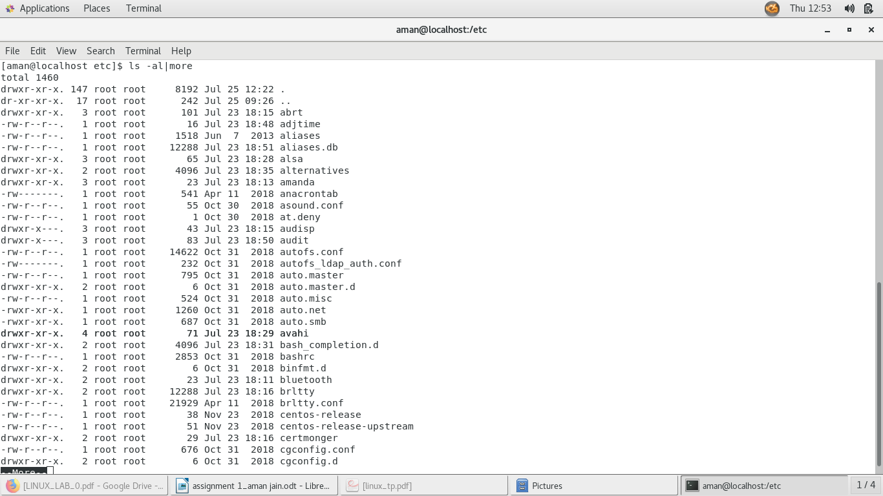
q).cd
r).pwd
3).
(a).change home directory of another user directly,using cd”username”
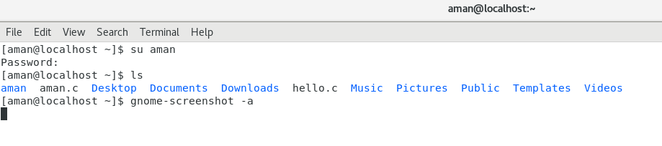
b).change back into your home directory
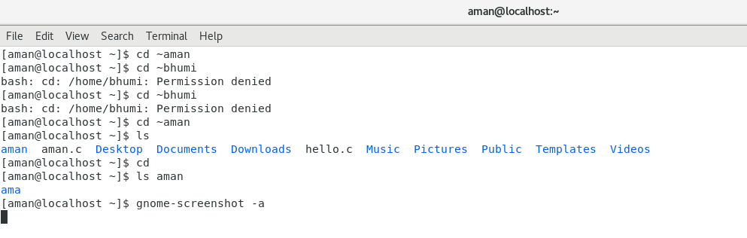
4.
a).make subirectories called work and play
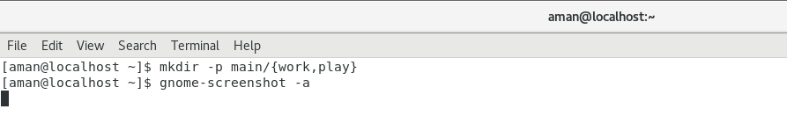
b).delete the subdirectory called work
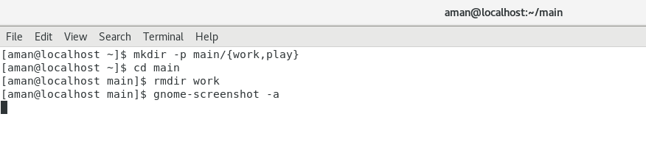
c).copy the file/etc/passwd into your home directory
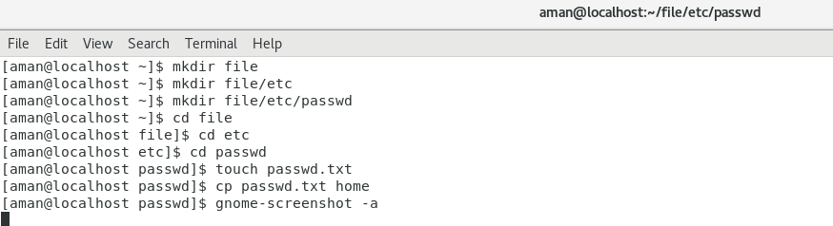
d).move it into the subdirectory play
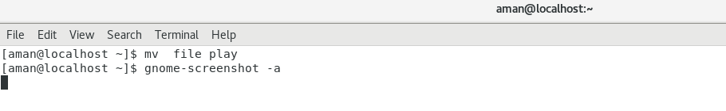
5).Dfference between a hard link and soft link
Dfference between a hard link and soft link is that hard link is the direct reference to the file whereas soft link is the reference by name which means it points to a file by file name. Hard link links the files and directories in the same file system, but the Soft link can traverse file system boundaries.

7).difference between ls l and ls L
ls is a shell command that lists files and directories within a directory. With the -l option, ls will list out files and directories in long list format. -l showing long listing format while -L, --dereference when showing file information for a symbolic link, show information for the file the link references rather than for the link itself

8).create a file called hello.txt and same effect by cp command terminal
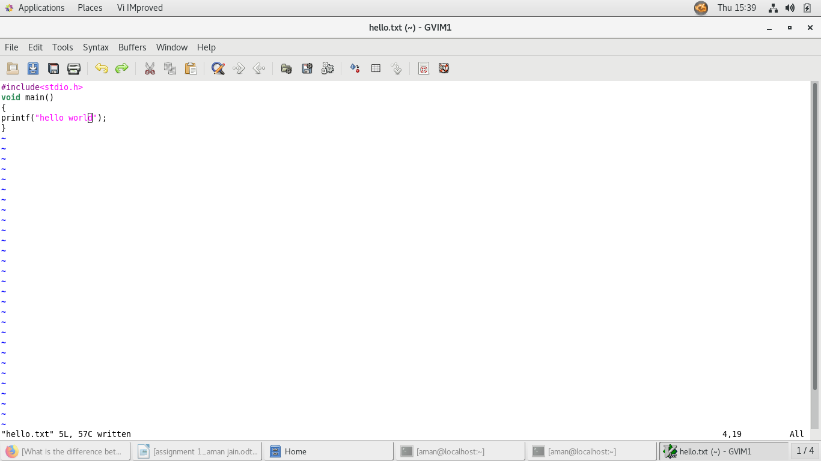
9).copy hello.txt to terminal
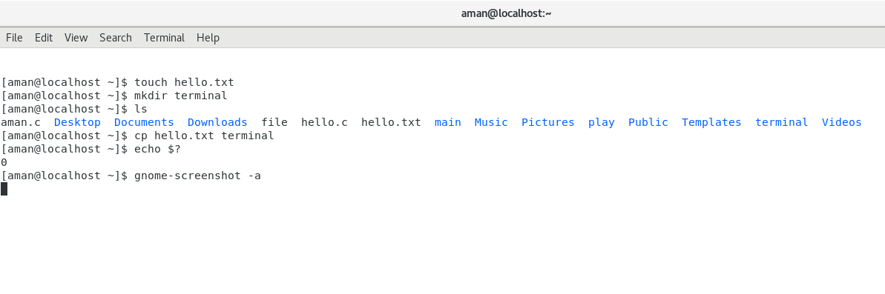

10).create and delete file called $SHELL
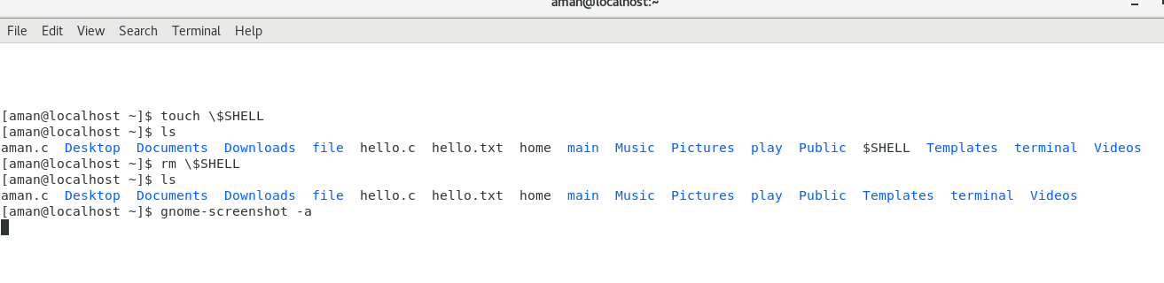
11).output of given command

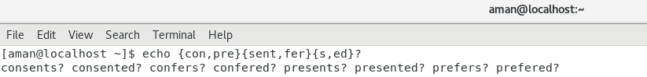

13).delete work directory and its contents with one command
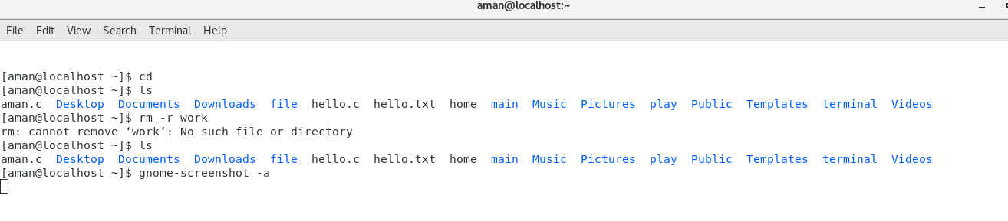

15).
a).ls
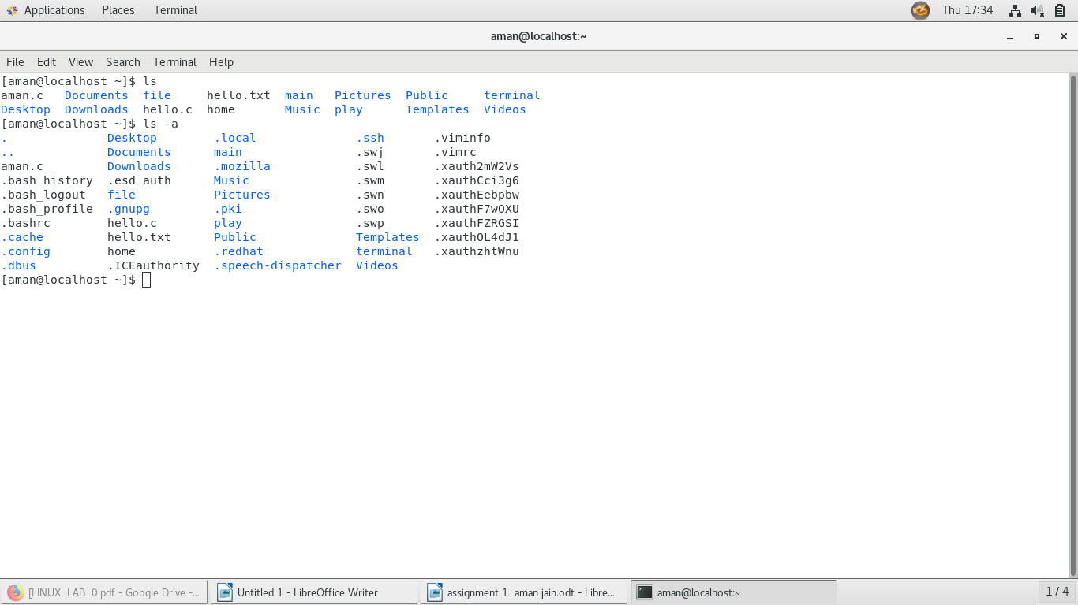
c).mkdir
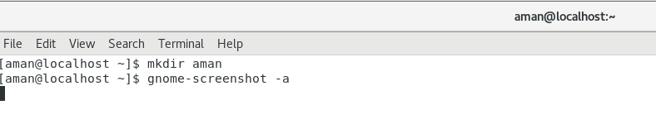
d).rmdir
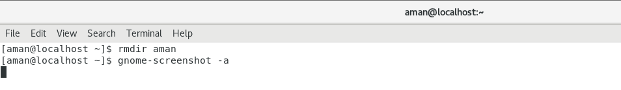

NAME-AMAN JAIN
EXERCISE 2
1).Describe three different ways of settings the persmissions on a file or directory to rrr. Create a file and see if this works
chmod u=r g=r o=r file.txt
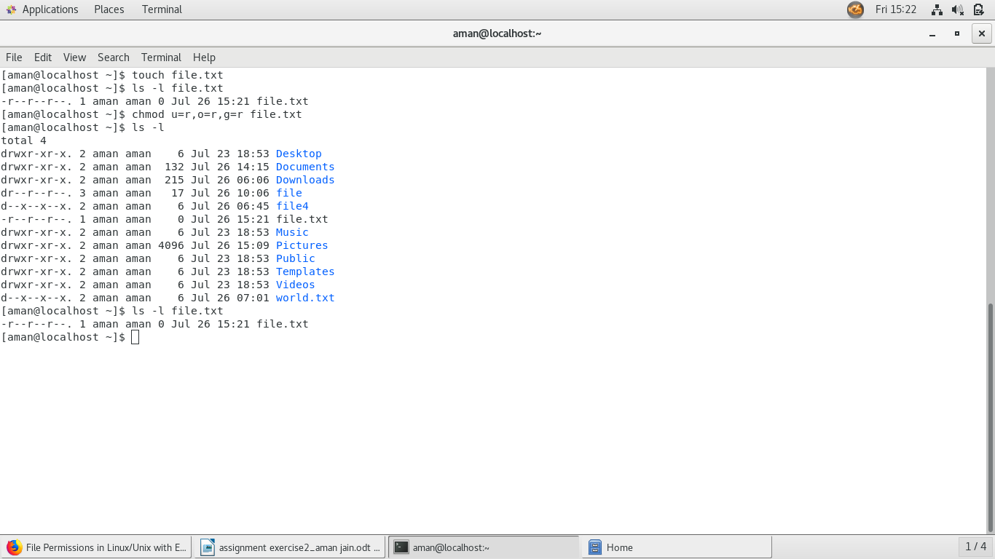
chmod

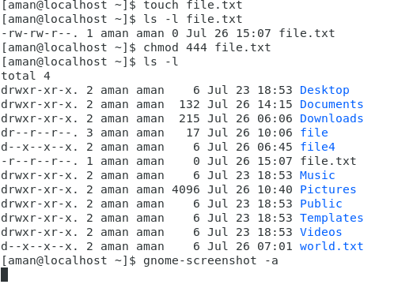

changing ownership to group
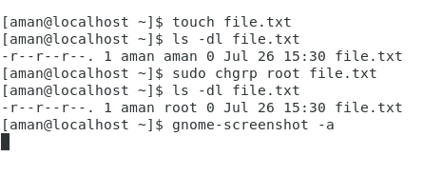

2). type umask 0000 and create hello world.txt containing the words hello world
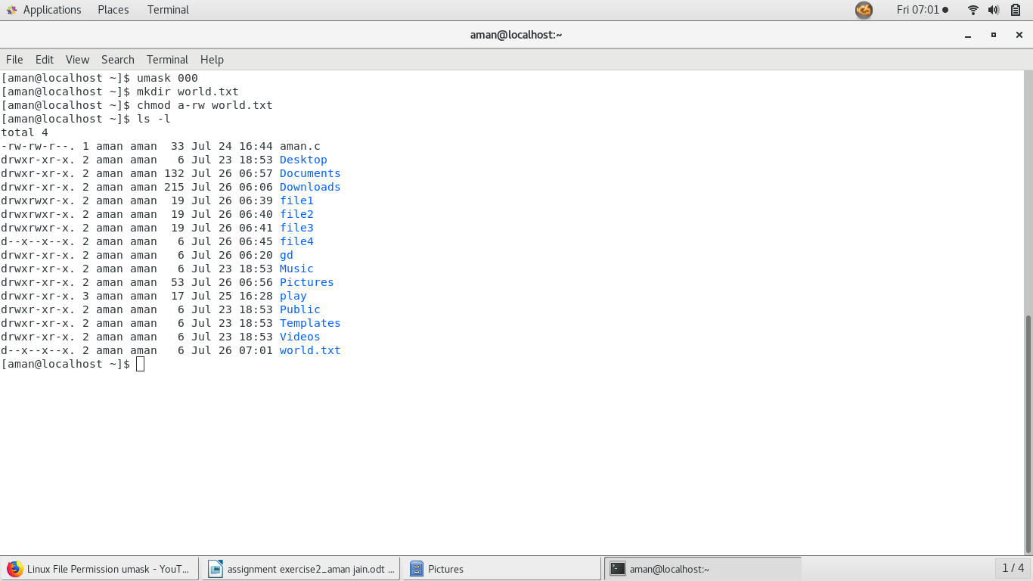

now type mask 022 and create a file called world2.txt
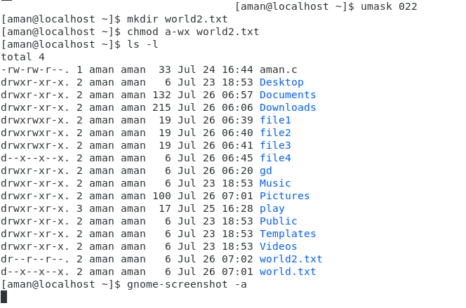
3).display names of all files
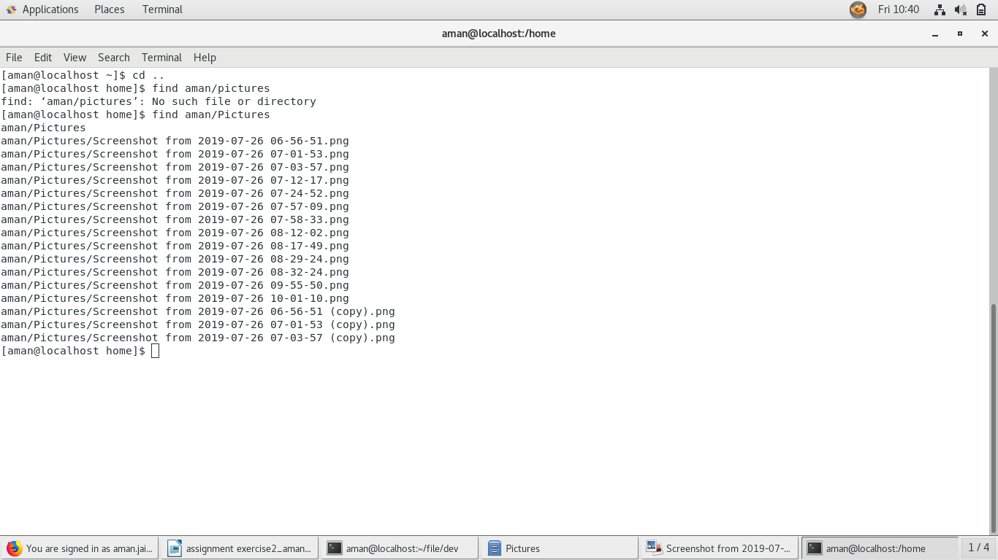

4).display all files bigeer than 1mb
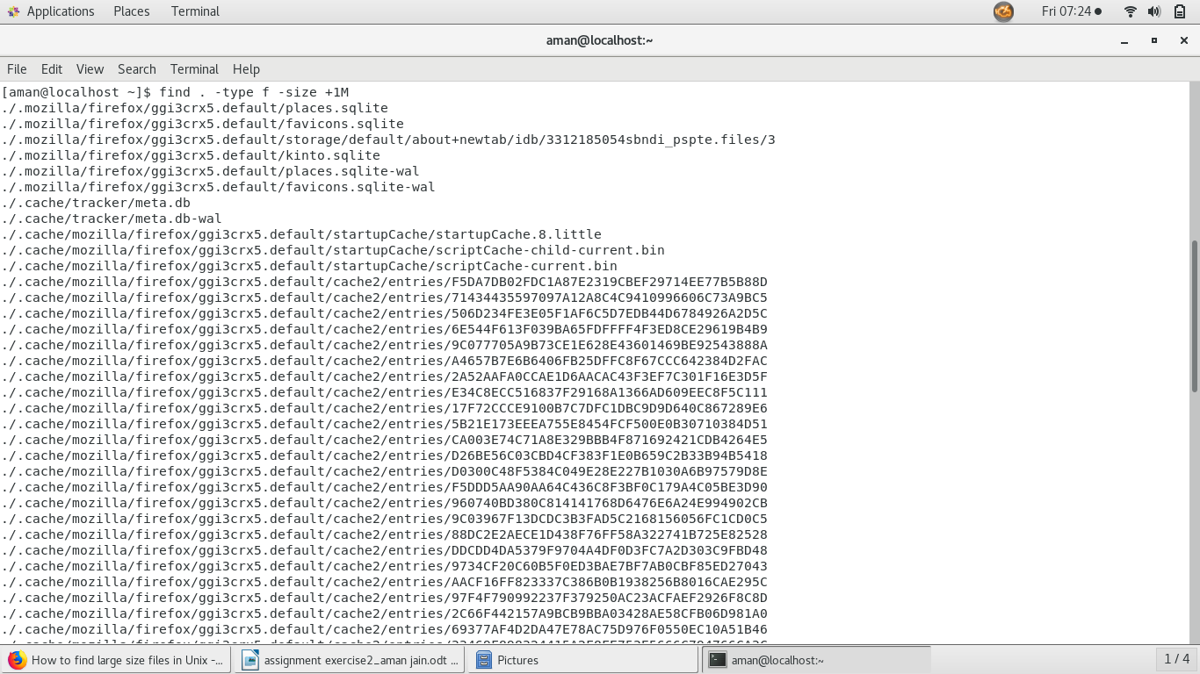
5).
use find and file to display all files the home/ subdirectory tree

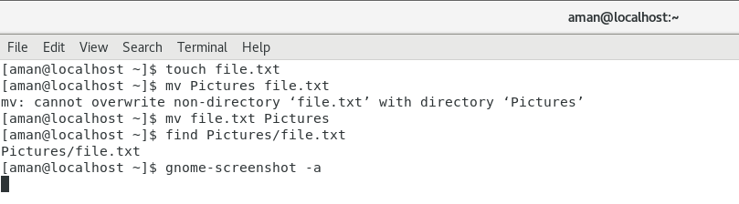
6).use grep to print /etc/passwd
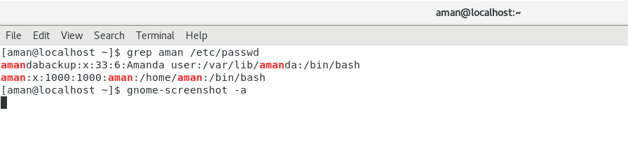

7).use find and grep and sort to display a sortedlist of all files in the home/subdirectory tree that contain word hello somewhere inside them
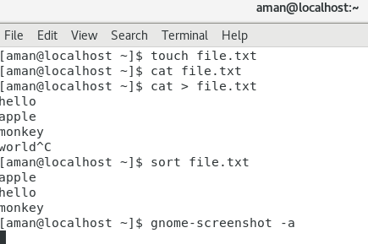

8).
use locate to find all filenames that contain the word emacs
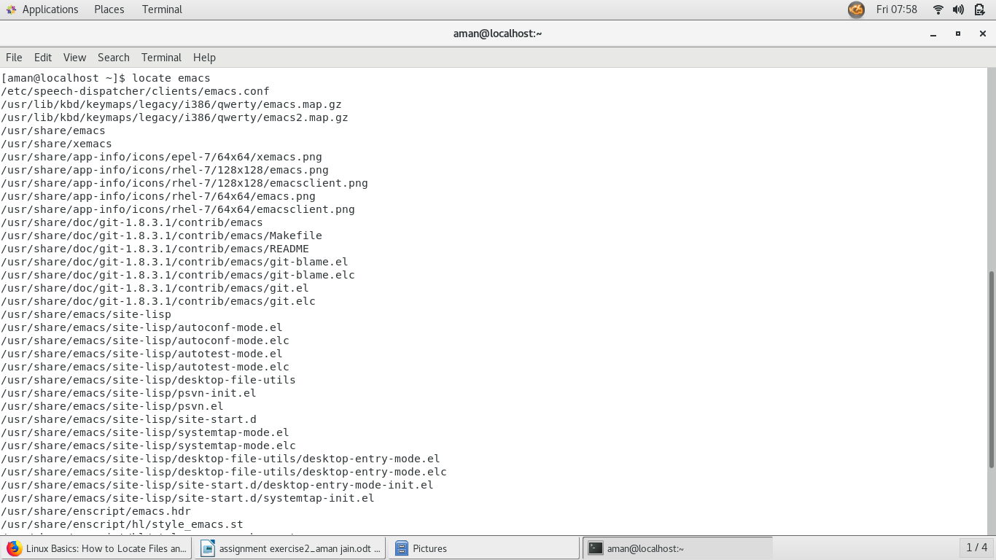

9).
archive contents using cpio
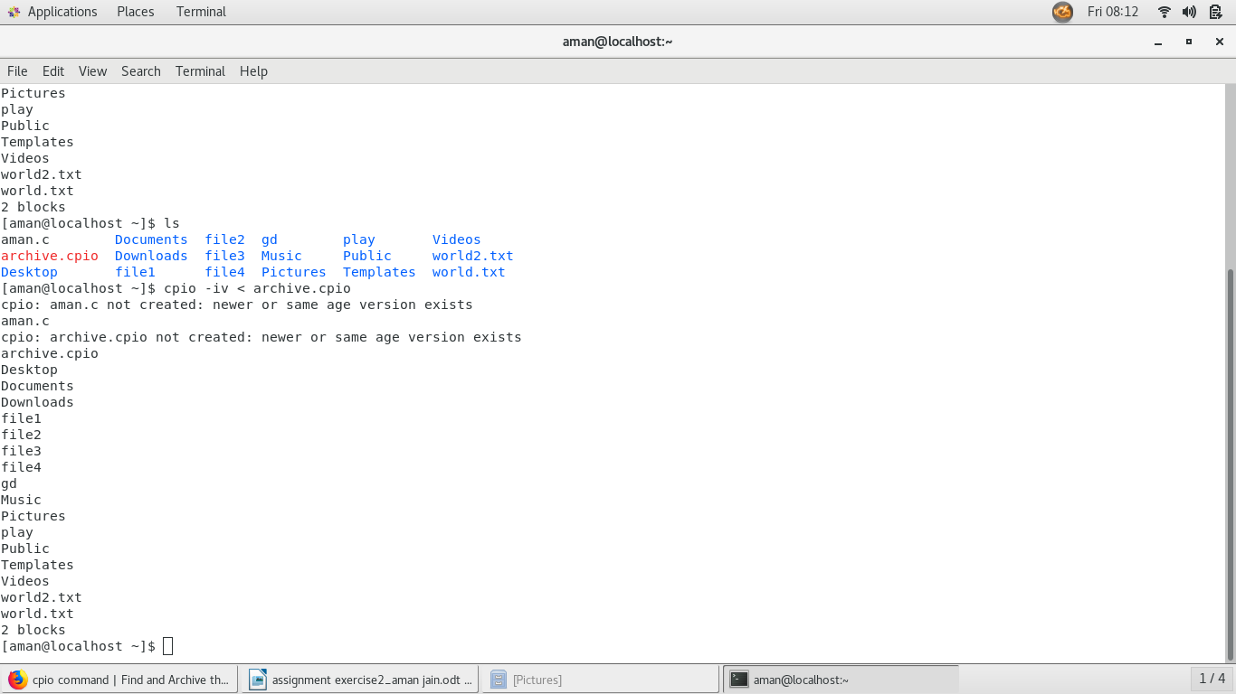
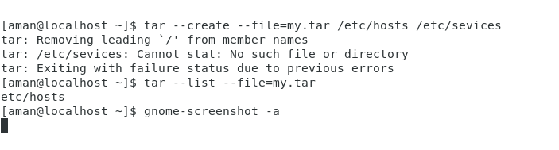
archive contents using tarcompress tar archive file
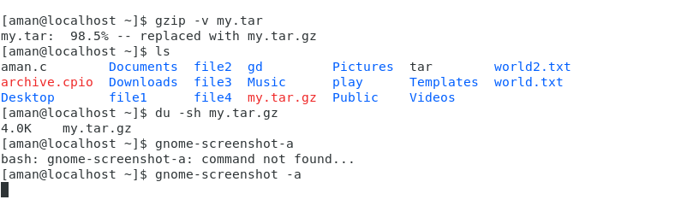

10).On the linux systems the file/dev/urandom is a constantly generated random stream of characters. Can you use this with ‘od’ to print out a random decimal number

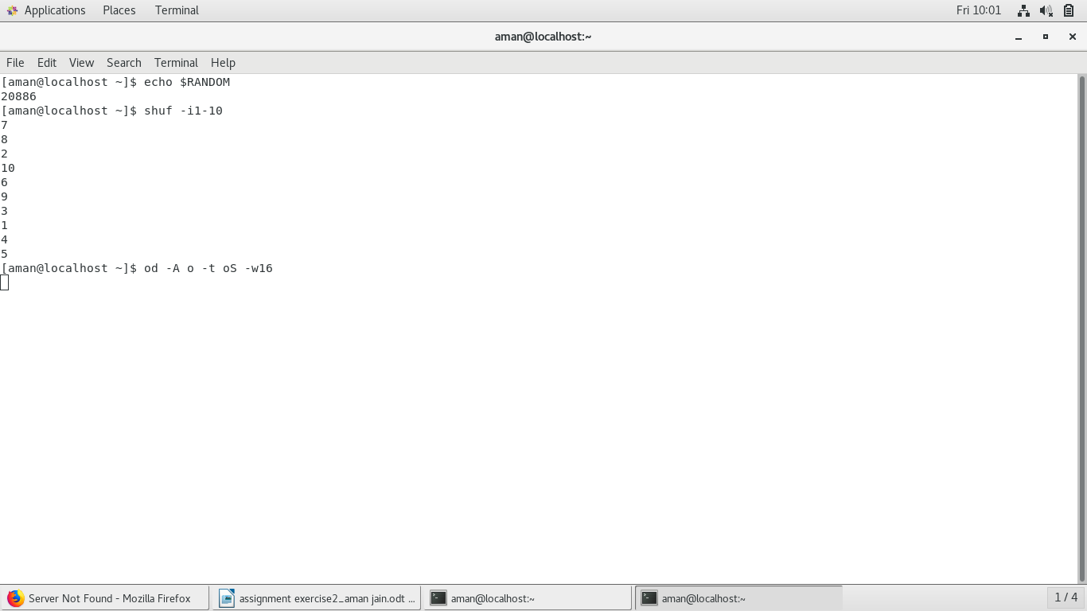
11).type mount and interpret output
